 Belair Middle School

***Parent and Family Engagement Policy and Plan for Shared Student Success***

*Plan Revised 4.30.25*

*2025–2026 School Year*

#### Belair Middle School CaVana Lambert, Principal 150 Potential Way, Augusta Ga 30909

*(706) 706= 737-7301*

[*www.rcboe.org*](http://www.rcboe.org)

# What is Title I?

Belair Middle School is identified as a Title I school as part of the Every Student Succeeds Act (ESSA). Title I is designed to support State and local school reform efforts tied to the challenging State academic standards to improve teaching and learning for students. Title I programs must be based on effective means of improving student achievement and include strategies to support family engagement. All Title I schools must

jointly develop with parents and family members a written

parent and family engagement

policy.

# School Plan for Shared Student Achievement

## What is it?

This is a plan that describes how Belair Middle School will

provide opportunities to improve family engagement to support

student learning. Belair Middle School values the contributions \

and involvement of parents and family members to establish an

equal partnership for the common goal of improving

student achievement. This plan describes the different ways that Belair Middle School will support family engagement and how parents

can help plan and participate in activities and events to promote student learning at school and at home.

## How is it revised?

Belair Middle School invited all parents to attend our annual School Revision/Input Forum last spring to review and revise this parent and family engagement policy, as well as the schoolwide plan, our school-parent compact, and the family engagement budget. Additionally, parent input and comments regarding this plan are welcome during the school year. The plan is posted on our school website for parents to view and submit feedback throughout the year. All parent feedback received during the year will be used to revise the plan for the next school year. We also distribute an annual survey online to ask parents for their suggestions on the plan and the use of funds for family engagement. Parents and family members can also give feedback during several parent meetings and activities during the school year. If the plan is not satisfactory to the parents of participating children, the school will submit any comments to the district office.

## Who is it for?

All students participating in the Title I, Part A program, and their families are encouraged and invited to fully participate in the opportunities described in this plan. Belair Middle School will provide full opportunity for the participation of parents and family members with limited English, with disabilities, and of migratory children.  **Where is it available?**

At the beginning of the year, the Richmond County Parent and Family Engagement Plan is included in the student code of conduct book that is given to all students. The Belair Middle Parent and Family Engagement Plan will also be posted on the school website and distributed at the Title I Annual Meeting. Parents can also retrieve a copy of the plan in the Parent resource center.

2025–26 District Goals

* During the 2025-2026 school year, we will increase student content mastery in tested subject areas on the Georgia Milestone by 6%.
* During the 2025-2026 school year, we will increase post-high school readiness by increasing our graduation rate by 2%.

2025–26 School Goals

* During the 2025-2026 School Year, we plan to increase school-wide numeracy by 10% as evident on the GMAS for Math.
* During the 2025-2026 School Year, we plan to increase school-wide literacy by 10% as evident on the GMAS for ELA.

# School-Parent Compacts

As part of this plan, Belair Middle and our families will develop a school-parent compact, which is an agreement that parents, teachers, and students will develop that explains how parents and teachers will work together to make sure all our students reach grade-level standards. The compact will be reviewed and updated annually based on feedback from parents, students, teachers and all other stakeholders. The school- parent compacts are shared with parents during open house, the Title I Annual Meeting, online, during parent teacher conferences

**Let’s Get Together!**

Belair Middle School will host the following events to build the capacity for strong family engagement to support a partnership among the school, parents, and the community to improve student academic achievement. Most meetings for parents and family members will be held in the morning before school, during the day by appointment and in the evening at 6:00 pm. for special events.

##### Open House

##### Infinite Campus Training, available school extra curriculum activities, parent volunteer opportunities

##### Parents As Students & PTO

Parents experience in one night what their child(ren) experience daily in the classroom.

##### Volunteer Workshop, PTO & Annual Title I Meeting

We invite you to an evening of learning about our Title I program, family engagement policy, the schoolwide

plan, and the school-parent compacts. Information provided via flyers, the marquee

##### Parent-Teacher and Student Conferences

Scheduled updates on your child’s progress.

##### Thankful for our Parents as Partners

Invite parents to have lunch with their children to foster a positive environment between the school and parents.

##### Family Fun Night: STEAM, PTO & Science Fair

Catch up with the latest resources in science, technology, engineering, arts, and math to help support your child’s learning.

##### Book Fair

Come purchase a book from the fair

##### Parent-Teacher Conferences

Connect with teachers about how your child is progressing academically.

##### Teacher Appreciation

Take time to thank a teacher and show appreciation for those who help shape your child.

##### Georgia Milestones Testing Window

GMAs testing window for 3rd -5th grade students.

***School Input/Revision Forum –*** Roundtable discussions with staff regarding the schoolwide plan, policy, compacts, and the budget.

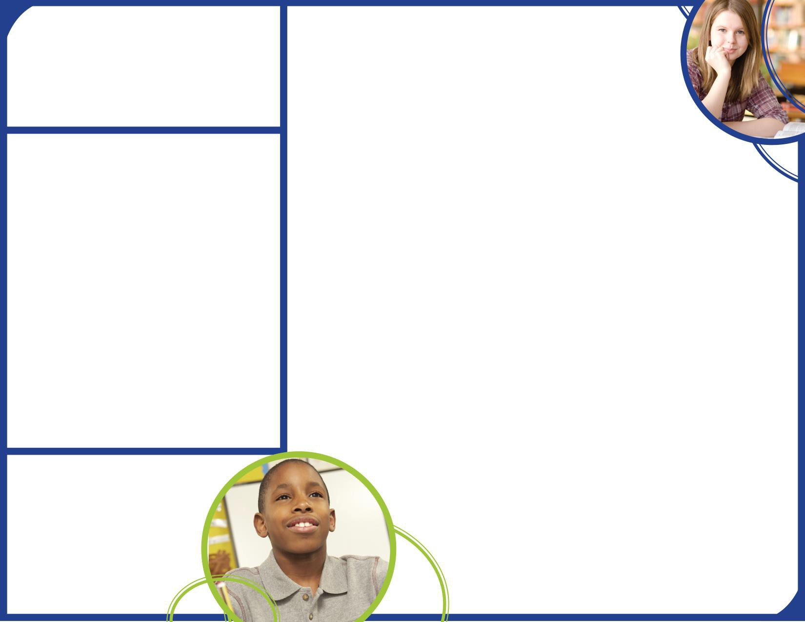**Parent Resource Center**

Come visit the Parent Resource Center (Media Center) to check out books, study materials, and activities to use at home with your child. Computers are available for parents to explore the Parent Portal and educational resources.

Monday – Friday, 9:00 am – 4:00 pm

**Parent and Family Engagement**

Belair Middle School believes that family engagement means the participation of parents and family members in regular two-way, and meaningful communication involving student academic learning and other school activities, including ensuring:

* That parents play an integral role in assisting their child’s learning.
* That parents are encouraged to be actively involved in their child’s education at school.
* That parents are full partners in their child’s education and are included, as appropriate, in decision-making and on advisory committees to

assist in the education of their child.

* The carrying out of other activities as described in this plan.

Belair Middle School is committed to helping our parents and families attend the family activities listed in this policy.

Please call us if you need assistance with

child care or transportation in order to participate in our programs. We must have a 48 hour notice.

(706)796-

## Belair Middle School is Branching Out!

Belair Middle School will take the following measures to promote and support parents and family members as an important foundation of the school in order to strengthen the school and reach our school goals. We will:

* + Ensure that all information related to school and parent programs, meetings, and other activities is published in an understandable format and language and posted on the school website.
  + Provide training for staff on strategies to improve communication with parents and ideas to increase family engagement with reading and math activities for our students outside of the classroom. Staff will also share best practices during regularly scheduled faculty meetings.
  + Partner with early*,* high schools, college and career ready resources or organizations, parent resource centers, or other programs (as applicable) to help prepare parents and their children for successful school transitioning.
  + Share information for parents to understand the school’s curriculum, academic standards and assessments as well as the ways parents can monitor their child’s progress and work with educators. Provide parents with individual student assessment results and interpretation of those results.
  + Communicate with all families and the community on a regular basis regarding schoolwide events and activities, through phone messages, the school website, and flyers.
  + Work with our parents to develop relevant trainings and helpful presentations to educate our staff on the importance of parent and family engagement and how to support student learning.
  + Provide necessary materials and handouts for parents at conferences, meetings, and activities to help parents work with their child to improve their child’s achievement. These meetings

will be offered at various times (morning and evening) and in various formats.

* + - Offer Infinite Campus account set up and assistance with usage for parents and family members to monitor their student’s progress.
      * Collect feedback from parents and family members at all events and post a survey on the school website in order to respond to parents’ requests for additional support for parent and family engagement activities.

# Parent and Family Engagement Standards

Belair Middle School and our parents have adopted the National PTA Standards for Family-School Partnerships as the school’s model in engaging parents, students, and the community. These standards are:

1. Welcoming All Families
2. Communicating Effectively
3. Supporting Student Success
4. Speaking Up for Every Child
5. Sharing Power
6. Collaborating with Community

# School Council

Belair Middle School has developed a School Council to share ideas and ways to involve other parents and family members to build partnerships with school, families, and the community. The School Council meets four times during the school year, but all parents and family members can also submit their ideas or suggestions at any of the school activities and meetings, as well as through our parent surveys and website.

# School Volunteer

* Yes, I am interested and wish to be trained and join the School Volunteer Team.
* Please contact me so I can learn more in joining the School Volunteer Team.
* Please send me notifications about future Volunteer Training Workshops.

Name: Child’s Name and Grade: Address: Phone Number: Email address:

# Share Your Thoughts

We want to hear from you. If you have any suggestions or if there is any part of this policy that you feel is not satisfactory with the students’ and the school’s goals for academic achievement, please provide us with your comments in the space provided and leave this form in the Main Office:

Name: (optional) Telephone Number: (optional)